CIT 225 Lesson 01 notes

Modern Databases
Modern database management systems are constantly evolving because the market demands new features. Current trends in database technology focus on two areas – Online Transactional Processing (OLTP) and Online Analytical Processing (OLAP) databases.
An OLTP database supports what we know as the “day-to-day” tasks of business. OLTP database support highly concurrent systems that add, change, and delete data. An OLAP database supports the underlying data that Data Analyst use to make decisions. Business Intelligence (BI) describes the data analysts’ world, and BI relies on OLAP databases to support and house data. OLAP supports concurrent systems that only query data
An OLAP database is a data warehouse when it contains large amounts of data to support a variety of decision-making. An OLAP database is a data mart when it contains a highly specialized data to help identify specific decision-making.
Day-to-day business operations typically run on relational database management systems (RDBMS). That’s because they’re designed to support high concurrency with and frequent data changes. Data changes come from INSERT, UPDATE, and DELETE statements, which respectively add, change, and remove data from a database.
The RDBMS is not the only solution available. Some companies choose to implement distributed systems, like Cassandra. Other companies choose to implement document-oriented databases, like MongoDB. You can describe a document-centered database as a content management database.
You also can implement an XML databases as a content management database. Mark Logic is an XML database. XML databases offer highly concurrent and query-only databases. They are effective alternatives to traditional OLAP solutions. XML databases are ideally suited solutions when we don’t know what we want to discover because they use XPath to find new relationships between data.
A database management system is generally suited to a single purpose. Unfortunately, sometimes organizations don’t have enough money to fund separate OLTP and OLAP databases. These companies often implement an RDBMS database to handle both the OLTP and OLAP needs. The database generally under performs its OLTP to deliver a qualified OLAP system and vice versa.

Database History
Databases evolved from a collection of files. Each file contained something unique. As a rule, the unique thing was a single subject or fact. Unfortunately, the cost of managing file systems led to the development of a Hierarchical Linear Model for storing information. A Hierarchical Linear Model is often called a hierarchical database and works very much like an XML structure.
A hierarchical database typically starts with a single root node. The root node typically one or more dependent children. The children are child nodes. Each child may have one or more siblings or sibling nodes. It is possible that a child node has children of its own. They are grandchild nodes from the perspective of the root node and child nodes from intermediary parent node. There is no limit to the depth of a node tree but those nodes without dependents or child nodes are leaf nodes. More or less a hierarchical model is like an inverted tree because the root node is at the top instead of deep in the ground below the tree. The leaves or leaf nodes are at the bottom instead of reaching for the sky.
Hierarchical databases work best when you compare data between sibling (side-by-side) nodes. The cost of comparing data between nodes becomes more expensive as they become farther apart. The collection of programs that manage a Hierarchical database are called a Database Management System (DBMS).
The structure of an inverted node tree is the problem with hierarchical databases. A good engineer tries to organize the data into single subjects, which are the nodes. Then, a good engineer tries to group related subjects under the same parent node. Unfortunately, some queries need to gather indirectly related subjects, which may be stored under different parent nodes. This type of design makes some queries cost far more than others.
Good engineers also improve their solutions as they learn from them. For example, they recognized that hierarchical databases were too inflexible for solving dynamic query results. The engineering solution was elegant and simple. They created networked database, which effectively added a map to each node in the tree. The map was called a pointer because it would act as an indirect reference to data found elsewhere in the tree. The problem with this approach was somebody had to maintain the pointers as other developer’s queries were developed or modified.
The cost of maintaining all the pointers in networked databases was too high. The engineers created relational databases to automate the maintenance of pointers. They put the pointers into another set of tables, which are called indexes. The collection of definitions about the tables or nodes and their search optimizing pointers are stored in a special subordinate database. The subordinate database is called a database catalog or data dictionary. The data that describes all the other data is metadata. Metadata is simply data about data.
Relational database management systems (RDBMSs) are a collection of programs that manage databases. An RDBMS discovers and maintains the ordinary data and the data that describes the data. The data that describes the data exists in a database catalog or data dictionary.
Structured Query Language (SQL) limits your access to these self-managing catalog or dictionaries. SQL is actually a shortened form of IBM’s original SEQUEL (Structured English Query Language), which conflicted with an English trademark but some thinks it simply doesn’t stand for anything.
The people who use a database are varied. You have programmers, analysts, engineers, database administrators (DBAs), and users. You can divide the users into many groups but the seminal work of Alvin Toffler – PowerShift: Knowledge, Wealth, and Violence at the Edge of the 21st Century labels these users as knowledge workers. If you want an updated, lengthier, tomb please check The World is Flat by Thomas Friedman.

SQL Engine
The DBMS subsystems manage Data Definition Language (DDL), Data Manipulation Language (DML), Data Control Language (DCL), and Transaction Control Language (TCL) commands. Occasionally, SELECT statements (queries) are removed from the DML group and placed in a Data Query Language (DQL). The argument goes that a query that doesn’t lock data for transactions isn’t manipulating it, it is only viewing it. The argument against that logic is that queries manipulate data to look at results. While an interesting topic, most certification material treats a SELECT statement as a DML statement.
Data Manipulation Language (DML) →
This gives you a brief description of the SELECT, INSERT, DELETE, UPDATE, and MERGE statements. These statements let you query data and transact against data in the database.
- SELECT – Queries data.
- INSERT – Inserts data into tables or objects.
- UPDATE – Updates data in tables or objects.
- DELETE – Deletes data from tables or objects.
- MERGE – Inserts or updates data based on conditions within the statement into tables or objects. It is part of the ANSI SQL:2003 standard. MySQL implements it as the ON DUPLICATE KEY clause, and you can find a comparison of the Oracle MERGE to it in this blog post.
Data Definition Language (DDL) →
This gives you a brief description of the CREATE, ALTER, DROP, RENAME, COMMENT, and TRUNCATE statements. These statements let you create, modify, and remove structures from the database.
- CREATE – Creates an object, which can be a table, view, or other structure supported by the DBMS implementation.
- ALTER – Alters the structure of an object, which can be a table, view, or other structure supported by the DBMS implementation.
- DROP – Drops a structure from the database, which may be constrained when there are other objects with a dependency on the target object.
- RENAME – Renames a structure, which can be a table, view, or subcomponent like a column name or data type of a table.
- TRUNCATE – Truncate deletes data like the DELETE statement with a twist. It preserves the structure of the table but deletes the contents without logging the deletes for recovery. Implementations vary between products, and Oracle’s flashback technology does provide for recovery of truncated objects.
- COMMENT – Lets you add a comment about a table, or a comment about a column in a specific table.

Two-tier Databases
All database management systems are two-tier (or implementations of the client-server model). They have a server and a client. The server runs a listener and the listener runs as a background process listening for client calls to the database. The client runs the software that lets you send messages to the server.
The client-side interface is frequently called the Oracle client, MySQL client, et cetera. It is always deployed on the server-tier but can be deployed as a standalone application on a separate client- or middle-tier server. This type of deployment lets you connect to work on server-side components or administer the server from a remote machine.
The client-side application software provides the interface. It allows you to create an Internet socket between two computers. This type of connection is often labeled persistent or pessimistic. It is persistent because it’s like a traditional handshake, unbroken until the reply and acknowledgment transaction completes. It is pessimistic because you remain connected until you confirm the completion of an action, which is known as a transaction. The supporting Internet socket is often described as state-aware. This type of communication allows interactive and batch communication to lock data changes until you want to make them publicly available in a multiple-user system. All database management systems are designed to be multiple-user systems and ACID-compliant machines.
While transactions may involve inserting, updating, or deleting data from a table or view, they may also involve transactions against multiple tables or views in the database. The perspective of a change or multiple changes to several objects is a transaction. Individual table changes in the context of a series of changes may be considered subtransaction. Likewise, a transaction may be broken up into smaller pieces, which are known as subtransactions. Subtransactions may contain one or more Data Definition Language (DDL) or Data Manipulation (DML) commands.
Anytime you have a client-side application communicating across an Internet socket, you have what’s known as client-server computing or multitier computing. The best definition I’ve run across for client-server computing is: “Two computers sharing resources across a network.” While you can implement this without TCP/IP, most applications implement it on top of TCP/IP.
Oracle® Client SQL*Plus →
This segment describes and illustrates the SQL*Plus environment that supports all command-line, Open Database Connectivity (ODBC), and Java Database Connectivity (JDBC) interactions.
The Oracle client is known as sqlplus, and it is an elaborate interactive and batch shell. sqlplus supports customizable environment variables and a set of very useful reporting tools. The complete documentation on the SQL*Plus environment can be found in Oracle SQL*Plus User’s Guide and Reference.
The basic architecture of the Oracle SQL*Plus environment is rather complex, which is why they’ve built such a competitive edge over the last two decades in the database market. The following drawing illustrates the flow of control for the Oracle SQL*Plus environment.
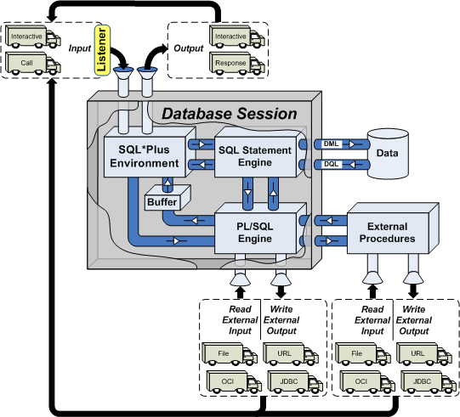
The ability to read and write external tables is not shown in the drawing and will be covered in Lesson 7 on Aggregation. It’s there because that’s where you learn how to create external tables, and import comma separated value files. Oracle also provides the ability to read and write proprietary files through a utility known as Oracle Data Pump, which is beyond the scope of the course.
There are two Oracle server-side components. They are the oracle daemon process that runs the RDBMS, and tnslsnr daemon process that runs the Oracle Listener.
You can find the documentation on the Oracle listener service in the Oracle Database Net Services Administrator’s Guide. The tnslsnr relies on the listener.ora server-side file to start and stop itself. The sqlplus executable uses the tnsnames.ora client- and server-side file to locate a database listener. The listener hears the sqlplus request and connects it to the oracle engine.

Select Statement
SQL Statement Behavior
Learning Outcomes
- Learn how to write SELECT statements.
- Learn how SQL executes SELECT clauses.
- Learn how SELECT statements can work independently or as subqueries.
Lesson Materials
The SELECT statement in SQL lets you query data. The designers of SQL felt the best programming languages would be ones that mirrored natural language. Therefore, the SELECT statement reads as an English sentence but underneath the syntax it runs in a traditional logical order of operation.
Each keyword in a SELECT statement is a clause. The clauses of a SELECT statement are the:
- SELECT clause or SELECT-list qualifies the columns returned by a query.
- FROM clause qualifies the table sources for a query and any table aliases.
- WHERE clause filters the pre-aggregated rows of the result set.
- GROUP BY clause identifies the column or set of columns that determines how values are aggregated (a fancy word for adding, averaging, counting, or calculating a value).
- HAVING clause filters the aggregated rows of the result set.
- ORDER BY clause sorts the rows returned by the query.
The general prototype of a SELECT statement from a single table or pseudo table is:
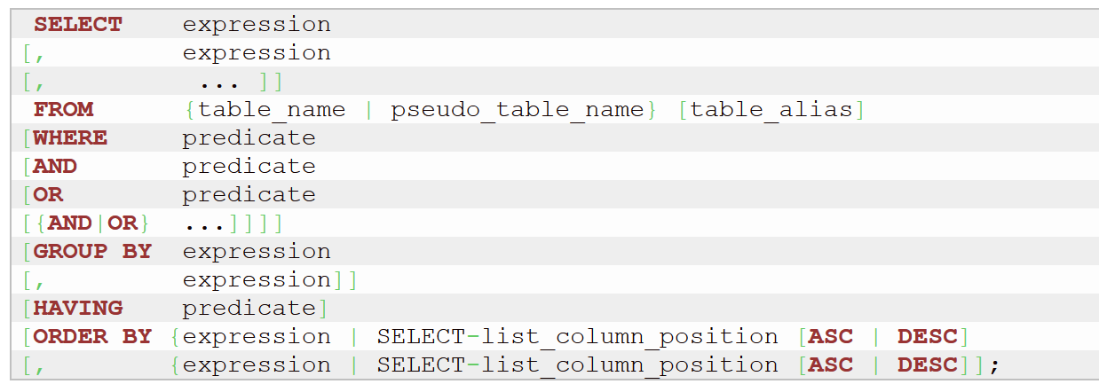
You should note that unlike some programming languages, you can’t write SQL statements with blank lines. Every SQL statement must have some correct element of syntax on each line. If you put a blank line in the SQL statement it will fails to run, and the error message will show you only that part of the SQL statement before the blank line.
The SQL specification labels expressions as numeric literal, string literal, computation, and concatenation values. Comparisons in the WHERE and HAVING clauses are predicates in the SQL specification.
The general prototype of a SELECT statement from a single table or pseudo table is:
The SQL specification labels expressions as numeric literal, string literal, computation, and concatenation values. Comparisons in the WHERE and HAVING clauses are predicates in the SQL specification.
The FROM clause above only holds one table but the FROM clause can hold a comma-delimited series of table or pseudo table names in ANSI 1989 style. The FROM clause can hold much more in ANSI 1992 style, such as the table names and join conditions. Multiple table FROM clauses are covered later after you’ve mastered single table SELECT statements.
The equal (=) symbol in the WHERE clause is a simplification to illustrate a general prototype. You can replace the equal symbol with a number of different comparison operators, which are covered in the WHERE Clause page on this website.
A value comparison operator may evaluate the content of the left column or literal value to see if it holds the same values as the right column or literal value. Alternatively, a comparison operator may evaluate the content of a left column or literal value to see if it holds the same values as a list of values in the right column. A list of values in this case may be a comma delimited list inside parentheses or the result set of an embedded SELECT statement, which is also known as a subquery.
While comparing values may seem simple to us as humans, it isn’t simple to computers. Before the value comparison operator can check whether the values are equal it must first ensure the left and right values (known as operands) have the same data type. If they don’t have the same data type, the database must cast one of them to the other data type before it can compare their values.
While data types are basically numbers, strings, and dates, there are a number of rules that govern them. Each database has rules that govern how a programmer can convert values to explicitly cast data types, but the Oracle database can implicitly cast between the following data types:
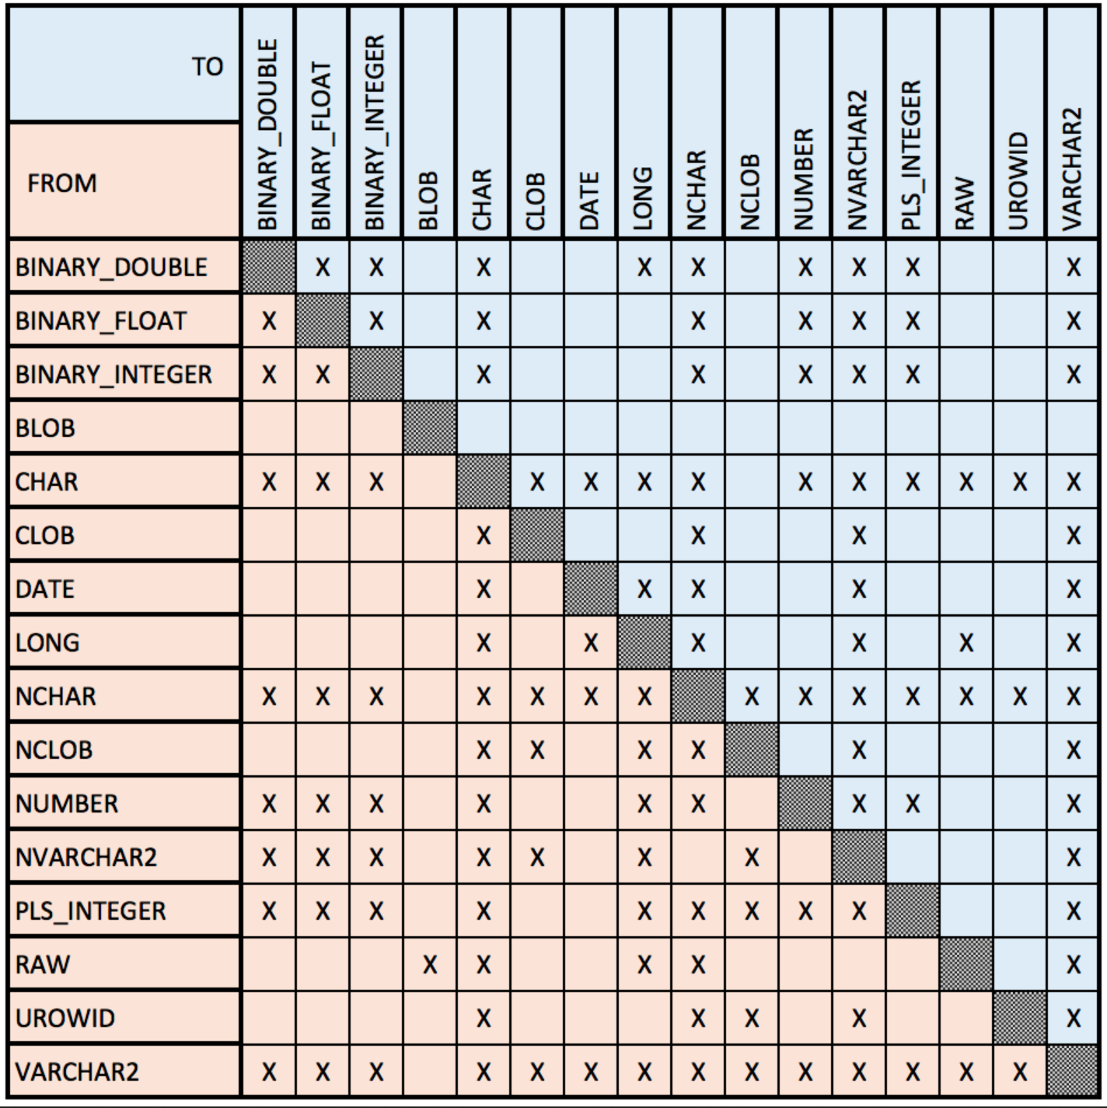
The execution order of the clauses in a SELECT statement differ in various scenarios. The scenarios and their execution orders are:
- A query with a SELECT-list and FROM clause; and they run in the following order:
  - The FROM clause finds the table or tables.
  - The SELECT-list returns the column or columns from a table or tables.
- A query with a SELECT-list, FROM clause, and WHERE clause:
  - The FROM clause finds the table or tables.
  - The WHERE clause filters the rows returned by the table or tables.
  - The SELECT-list returns the column or columns from a table or tables.
- A query with a SELECT-list, FROM clause, WHERE clause, and ORDER BY clause:
  - The FROM clause finds the table or tables.
  - The WHERE clause filters the rows returned by the table or tables.
  - The ORDER BY clause sorts the rows returned by the query.
  - The SELECT-list returns the column or columns from a table or tables.
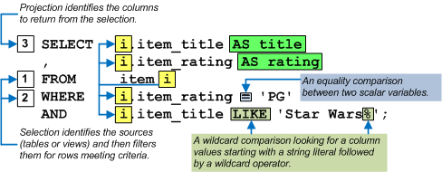
- A query with a SELECT-list, FROM clause, WHERE clause, ORDER BY clause, and GROUP BY clause:
  - The FROM clause finds the table or tables.
  - The WHERE clause filters the rows returned by the table or tables.
  - The GROUP BY clause aggregates the rows by identifying the column or set of columns that determines how values are aggregated.
  - The ORDER BY clause sorts the rows returned by the query.
  - The SELECT-list returns the column or columns from a table or tables.
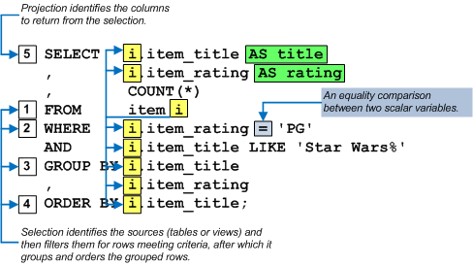
- A query with a SELECT-list, FROM clause, WHERE clause, ORDER BY clause, GROUP BY clause, and HAVING clause:
  - The FROM clause finds the table or tables.
  - The WHERE clause filters the rows returned by the table or tables.
  - The GROUP BY clause aggregates the rows by identifying the column or set of columns that determines how values are aggregated.
  - HAVING clause filters the aggregated rows of the result set.
  - The ORDER BY clause sorts the rows returned by the query.
  - The SELECT-list returns the column or columns from a table or tables.
SELECT statements may run as standalone statements or they may run as subordinate parts of other SELECT statements. You may also write SELECT statements inside INSERT, UPDATE, MERGE, and DELETE statements. You label a SELECT statement as a subquery when you put it inside another statement.
There are four types of subqueries:
- A scalar subquery returns only one column and one row.
- A single-row subquery returns one row with two or more columns.
- A multiple-row subquery returns two or more rows with two or more columns.
- A correlated subquery includes a join between the subquery and the outer statement but returns no values to outer statement.
The behaviors of the individual clauses are described in their respective web pages. You also have the ability to embed a subquery in the FROM clause. An embedded query in the FROM clause treats the result set of the query as a dynamic table. ANSI 1999 SQL introduces the WITH clause as an alternative to putting subqueries in the FROM clause.
A WITH clause runs before the rest of the query and it is a list of comma-delimited named SELECT statements. Each named SELECT statement is also known as a Common Table Expression (CTE) because it returns a result set. A WITH clause also precedes the primary SELECT statement. Each of the
The first SELECT statement in a WITH clause runs in isolation from any other SELECT statements in the comma-delimited list of named SELECT statements. All subsequent SELECT statements in list of named SELECT statements can refer to any of the previously named SELECT statements. The primary SELECT statement can reference all of the named SELECT statements in the WITH clause.
Below is the general prototype of a SELECT statement with a WITH clause. Each SELECT statement in the comma-delimited set may:
- Have any of the normal clauses defined in the general prototype of a SELECT statement or query.
- Reference one or more tables not that may be unrelated to the base table or tables of the SELECT statement. The SELECT statement may reference all result set name values from the comma-delimited list in the WITH clause.
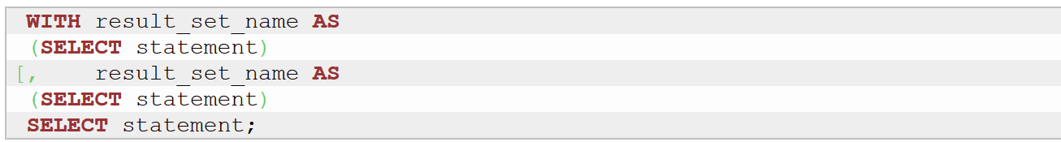
The named SELECT statements or CTEs inside the WITH clause return their results into memory. You can access the CTE values in multiple scopes within the primary SELECT statement. This ability replaces the older solution. The older solution was quite ineffective because it required you to write the same query as subqueries in multiple places and each copy ran independently in their respective scope.
The following image shows you a WITH clause with two comma-delimited named SELECT statements. The first named subquery is inline and the second named subquery is contact_list; and the results are joined together on line 13 of the contact_list named subquery. The primary SELECT statement returns the unfiltered result set from the join of the two named subqueries. You should note that this is effectively a multiple-row subquery, which can only be accessed in two contexts: inside the FROM clause as a CTE (or, run-time view) and as right operand of a lookup operator (IN, =ANY, =SOME, =AND).
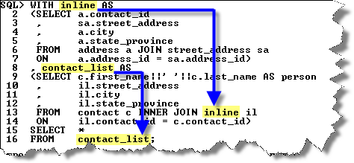
Subsequent web pages will demonstrate how to write subqueries and demonstrate how the WITH clause works with scalar, single-row, and correlated subqueries. They will also explain the concept of joining two or more tables together.

SELECT Clause

SELECT Clause
Learning Outcomes
- Learn how to work with comma delimited literal values.
- Learn how to work with comma delimited literal values with column aliases.
- Learn how to work with comma delimited column values.
- Learn how to concatenate literals and columns.
- Learn how to use math operators to add, subtract, multiply and divide literals and column values.
Lesson Materials
As explained in the SELECT statement page, the minimum SELECT statement has a SELECT clause or SELECT-list and FROM clause. The SELECT-list is a comma delimited set of literals, column names, calculations of literals and column values. The FROM clause may reference one table or two or more tables.
Some modern databases support the ability to query string literals without referring to a table or they refer to a pseudo table. A pseudo table is essentially a placeholder value for a table in the FROM clause that lets you have one to many column values in a single row.
The pseudo table an Oracle database (as well as MySQL and SQL Server) is the dual table. Some of the examples use the dual table and others use a cereal table. You can download a script to create the cereal table from this URL on GitHub.com’s server.
SELECT-list
SQL (Structured Query Language) supports an asterisk (*), literal values, and column values. The asterisk (*) is a pointer or indirect reference to rows returned by the query. There are two types of literal values. They are numbers and strings. Strings are delimited with single quotes in most databases, like Oracle.
Date literals are strings that conform to the standard date format. Oracle supports two default string formats for dates. They are:
- One uses a two-digit number for day, a hyphen, a three digit string abbreviation for month, a hyphen, and a two-digit number for a relative year:
DD-MON-RR
- One uses a two-digit number for day, a hyphen, a three digit string abbreviation for month, a hyphen, and a four-digit number for an absolute year:
DD-MON-YYYY
Literal Values
This section shows you how to return literal values, concatenate (or glue together) literal strings, and perform basic mathematics by assigning aliases to these literal values and results from concatenation and math operations.
Instruction Details ←
The query shows you that you must use single quotes to delimit a string literal value. It also shows you how to use a column alias. The AS keyword is option in most databases but using it makes reading your aliases simpler. Aliases in a SQL context must begin with a letter or underscore and may contain letters, numbers, and underscores.
The query also uses a FROM clause with the dual pseudo table, which effectively lets you select a string not otherwise found in a table within the database.
SELECT 'Hello World!' AS string
FROM dual;

The query returns the following string literal value with a column header set by the column alias of the query.
STRING
------------
Hello World!
You have the ability to have multiple columns in a SELECT-list. The literal values or columns are comma delimited.
The next sample SELECT-list queries one string literal and another pseudo column that concatenates a string literal and date. Like the prior example, the FROM clause uses the dual pseudo table.
SELECT 'Hello World!' AS string
, 'Leap day is: ' || '29-FEB-2016' AS "Leap Year Day"
FROM dual;
The comma between the two literal values is like separating two columns from a table. They are effectively pseudo columns. The double pipe (||) command lets you concatenate (or glue two strings together as one). The “Leap Year Day” column alias is enclosed in single quotes, which lets you embed case sensitive strings and whitespaces.
The query returns the following two columns values:
STRING Leap Year Day
------------ ------------------------
Hello World! Leap day is: 29-FEB-2016
Column Values
This section shows you how to return column values, concatenate (or glue together) string column values, and perform basic mathematics. It also shows you how to assign conforming aliases and non-conforming aliases to SELECT-list values. A conforming alias starts with a letter and a non-conforming alias starts with a number or underscore.
Instruction Details ←
This section uses a cereal table. The cereal table has the following description:
Name Null? Type
----------------------------------------- -------- ----------------------------
CEREAL_ID NOT NULL NUMBER
MANUFACTURER NOT NULL VARCHAR2(24)
BRAND NOT NULL VARCHAR2(30)
MASCOT VARCHAR2(30)
OUNCES NOT NULL NUMBER(4,2)
SUGGESTED_RETAIL NOT NULL NUMBER(5,2)
The cereal table uses a cereal_id column as its primary key column. The manufacturer, brand, ounces, and suggested_retail columns are mandatory columns because they are not null constrained. You must provide a value for any mandatory columns when you try to add a new row to a table, whereas you can provide a null value to any optional columns. Optional columns are unconstrained.
You can get the cereal.sql file at this URL, and then you can run the script to create the cereal table and add seventy rows to it. If you put the cereal.sql file in the /home/student/Data/cit225/oracle/demo directory, you should launch SQL*Plus from that same directory assuming you have a student user with a student password, like:
sqlplus student/student
Inside SQL*Plus, you’ll see the SQL> prompt. You can run the file with the following syntax:
@cereal.sql
At the end of the cereal.sql script, it queries the number of rows found in the cereal table. The cereal.sql script includes SQL*Plus formatting commands. The COLUMN command is a SQL*Plus formatting command. You can use COLUMN keyword or its first three letters COL as an abbreviation.
The following COL command formats the rows column as a four digit number. The SQL*Plus HEADING clause and double quotes lets you reuse a title case Rows string as the title case displayed column name.
COLUMN ROWS FORMAT 9999 HEADING "Rows"
The following query counts the number of rows in the cereal table:
SELECT COUNT(*) AS "rows"
FROM cereal;
The double quotes around the keyword rows are required because the column alias rows is an identifier in Oracle’s implementation of SQL. The double quotes let you reuse a rows keyword as an ordinary column name.
The query should return the following because the COUNT(*) function counts the number of rows in the table (effectively the asterisk (*) is an indirect variable reference, or pointer, to the instances of rows in the table):
Rows
-----
70
You have the ability to query all columns in a SELECT-list by using only the asterisk (*), which is effectively a pointer complete rows. Unfortunately, Oracle’s SQL*Plus command-line interface (CLI) displays only 80 characters and most tables hold more than 80 characters, so you have the ability of limiting the SELECT-list by qualifying only the columns you want to see.
The following query returns the cereal_id, manufacturer, and brand columns. The SQL*Plus formatting commands set the cereal_id column to a four digit number, the manufacturer column as a twenty character string, and the brand column as a thirty character string.
While the SQL*Plus COLUMN command uses a FORMAT 9999 clause to format a number, a FORMAT A99 formats an alphanumeric string. A new SQL*Plus PAGESIZE command sets the line break to 999 rows.
COL cereal_id FORMAT 9999 HEADING "Cereal|ID #"
COL manufacturer FORMAT A20 HEADING "Manufacturer"
COL brand FORMAT A30 HEADING "Brand"
SELECT cereal_id
, manufacturer
, brand
FROM cereal;
The returns the following:
Cereal
ID # Manufacturer Brand
------ -------------------- ------------------------------
1 Kellogg Frosted Flakes
2 Kellogg Frosted Flakes
3 Kellogg Frosted Flakes
...
67 Kellogg Special K Original
68 Kellogg Special K Original
69 Kellogg Special K Red Berries
70 Kellogg Special K Red Berries
You have the ability to query all columns in a SELECT-list by using only the asterisk (*), which is effectively a pointer complete rows. Unfortunately, Oracle’s SQL*Plus command-line interface (CLI) displays only 80 characters and most tables hold more than 80 characters, so you have the ability of limiting the SELECT-list by qualifying only the columns you want to see.
The next sample SELECT-list queries three actual columns found in the table, and creates a fourth column by performing a calculation on mathematical result between two of the actual columns. The numeric columns use a combination of the LPAD and TO_CHAR SQL built-in functions to right align a number formatted as a string result.
The SQL*Plus formatting combined with the query below:
COL brand FORMAT A30 HEADING "Brand"
COL suggested_retail FORMAT A10 HEADING "Suggested|Retail"
COL ounces FORMAT A10 HEADING "Ounces"
COL cost_per_ounce FORMAT A10 HEADING "Cost|Ounces"
SELECT brand
, LPAD(TO_CHAR(suggested_retail,'$90.00'),10,' ') AS suggested_retail
, LPAD(TO_CHAR(ounces,'00.00'),10,' ') AS ounces
, LPAD(TO_CHAR(suggested_retail / ounces,'$0.00'),10,' ') AS cost_per_ounce
FROM cereal;
produces the following results:
Suggested Cost
Brand Retail Ounces Ounces
------------------------------ ---------- ---------- ----------
Frosted Flakes $2.50 17.00 $0.15
Frosted Flakes $3.47 19.00 $0.18
Frosted Flakes $3.99 27.50 $0.15
Chocolate Frosted Flakes $4.99 24.70 $0.20
Corn Flakes $2.50 17.00 $0.15
Corn Flakes $3.47 19.00 $0.18
...
Special K Original $2.50 12.50 $0.20
Special K Original $3.29 16.90 $0.19
Special K Red Berries $2.50 12.50 $0.20
Special K Red Berries $3.29 16.90 $0.19
These examples have shown you how to return actual columns and derived columns; and also how you format them for display in a SELECT-list.

FROM Clause

FROM Clause
Learning Outcomes
- Learn how to reference a pseudo table.
- Learn how to reference a table.
- Learn how to reference two tables.
- Learn how to reference three or more tables.
Lesson Materials
As explained in the SELECT statement page, the minimum SELECT statement requires a SELECT-list and FROM clause. All other clauses are optional clauses, like the WHERE, GROUP BY, HAVING, and ORDER BY clauses.
FROM Clause
The FROM clause qualifies the table sources for a query and any table aliases. The FROM clause supports two SQL specifications. They are ANSI SQL-89 and SQL-92.
SQL specification are defined by American National Standards Institute (ANSI). SQL1 was the first version of the specification formalized by ANSI in 1986. The formal name for SQL1 is SQL-86. SQL1 went through a minor revision but ANSI SQL-89 was accepted by Federal Information Processing Standards (FIPS). SQL2 was a major revision in 1992 and it added a natural join and several other features, including the CASE operator. The CASE operator lets developers perform conditional logic in queries and Data Manipulation Language (DML) commands, like the INSERT, UPDATE, MERGE, and DELETE statements.
SQL3 was a major release that included hierarchical and recursive queries, triggers, and Common Table Expressions (CTEs).
SQL3 was introduced in 1992. More often than not SQL1 and SQL2 are associated with comma-delimited table names in the FROM clause. SQL3 was a major revision of the SQL specification. SQL3 is associated with the use of table names with or without table aliases separated by join keywords, like the following:
- [CROSS] JOIN; the CROSS keyword is optional.
- FULL [OUTER] JOIN; the OUTER keyword is optional.
- INNER JOIN; the INNER keyword is optional.
- LEFT [OUTER] JOIN; the OUTER keyword is optional.
- NATURAL JOIN
- RIGHT [OUTER] JOIN; the OUTER keyword is optional.
The cross and natural joins do not use subclauses to qualify join relations. The cross join doesn’t use actually have a join relationship because it simply matches every row in one table with all the rows in the other table. The natural join on the other hand does use a join relationship, which is automatically determined by matching values of columns that share the same column names.
The inner, left, right, and full joins use subclasses to qualify join relations. These joins use either the ON or USING subclauses in the FROM clause. The ON subclause is generally available in most distributions of SQL but the USING subclause is not consistently available.
FROM Clause with a single table
The following query builds on the example in the GROUP BY clause by adding a HAVING clause. The HAVING clause filters only the aggregated row set. It returns only those rows that return an average cost per ounce greater than twenty-two cents.
1  2  3  4 | COL brand FORMAT A30 HEADING "Brand"  COL avg_per_ounce FORMAT A10 HEADING "Average|Cost|Ounces"  SELECT LPAD(TO_CHAR(AVG(suggested_retail/ounces),'$0.00'),10,' ') AS avg_per_ounce  FROM cereal;

It returns the following row from the seventy rows because the AVG function aggregates, or calculates the average of, all of the original seventy rows into one row:
Average
Cost
Ounces
----------
$0.21
You can only return aggregated functions without a GROUP BY clause, which you’ll see next.

WHERE Clause

SQL Statement Behavior
Learning Outcomes
- Learn how to compare two variables in a WHERE clause.
- Learn how to compare two variables when one or more holds a NULL value.
- Learn how to compare one variable against a range of variables with the BETWEEN operator when all are variables hold non-null values or one or more holds a null value.
- Learn how to use more than one comparison inside a WHERE clause.
- Learn how to use lookup values to find a value in a list of values.
Lesson Materials
Statements and queries have two phases and they differ. While statements and queries have two phases, they differ. A statement selects tables and filters rows by the WHERE clause, and then a statement acts on a row or set of rows.
The two phases of a query are selection and projection. Selection has two components like statements, and they are:
- The first component identifies the sources or tables in the FROM clause.
- The second component filters the rows returned by comparing values and evaluating whether the comparison is true or false.
WHERE Clause Selection
The WHERE clause of statements and queries filter rows based on several rules. The following qualifies the rules for comparative operations:
Two-value Comparisons
Two value comparisons work by comparing two values or variables of the same data type. Comparison operations may check to see if they are equal, less than, greater than, on in a set of values.
Instruction Details ←
Equality Comparison
The following compares a string variable to a string literal value:
WHERE string_variable = 'some string'
The WHERE clause returns true when the value of the string_variable column is equal to the case sensitive 'some string' and false when it isn’t equal. For reference, string literal values are delimited by single quotes, and they are case sensitive strings.
The following compares a numeric_variable column to a numeric literal value:
WHERE numeric_variable = 1.5
The contents of a numeric variable are compared to other numeric values, whether they are in other variable. The numeric comparison cast the two numeric values to the same type before comparing their values.
The following compares a date variable to a string literal that conforms to one of the date formats:
WHERE date_variable = '29-FEB-17'
The contents of a date variable is a scalar numeric value, which means it is a double precision number. The number to the left of the decimal point represents the day and the number to the right of the decimal point represents the hours, minutes, seconds, 10th of seconds, and 100th of seconds. Timestamps in databases are like dates but they also contain smaller increments of time, like 1,000th of a second.
Date-time comparisons are therefore like numeric comparisons.
Non-equality Comparison
The following compares a string variable to a string literal value:
WHERE string_variable > 'some string'
While the contents of a string variable are compared as a case sensitive string in most relational databases and string literal values are delimited by single quotes, they are compared based on their ASCII values.
The ASCII value of characters differs between character sets, like English, French, Japanese, and Chinese differ. In a Western European character set, a capital “A” holds a value of 65 and a lowercase “a” holds a value of 97.
That means a comparison like this is true:
WHERE 'A' > 'a'
and, a comparison like this is false:
WHERE 'a' > 'A'
The following compares a numeric variable to a numeric literal value:
WHERE numeric_variable > 1.5
When the numeric_variable holds a value greater than the numeric literal value the comparison is true, and when the numeric_variable holds a value less than the numeric literal value the comparison is false.
The following compares a date variable to a string literal that conforms to one of the date formats:
WHERE date_variable > '29-FEB-17'
When the date_variable holds a value greater than the date literal value the comparison is true, and when the date_variable holds a value less than the date literal value the comparison is false.
Three-value Comparisons
Three-value comparisons are required in database comparisons because you can define any column to accept null values. You can’t use an =, >, >=, <, <=, or <> operator to compare a value with a null value.
Instruction Details ←
Null Value Comparison
You have only one option when you want to compare a value and a null column value. You need to wrap the column value in an NVL() function call. The NVL() function replaces the column value with a default value, like the following:
WHERE NVL(string_variable,'default string') = 'some string'
You can use reference comparison operators to filter rows when a column value is null or when a column value is not null. You use the IS NULL to return true when the column value holds a null value and the IS NOT NULL to return true when the column doesn't hold a null value.
The following compares a null column value:
WHERE string_variable IS NULL
The following compares a not null column value:
WHERE string_variable IS NOT NULL
Range Comparisons
Range value comparisons exist to let you find a value in an inclusive range of values.
Instruction Details ←
Range Value Comparison
The rules work as follows:
- You provide a lookup value, which must be a not null value.
- You provide a lower range value, which must be a not null value.
- You provide an upper range value, which must be a not null value.
WHERE numeric_variable BETWEEN low_range_value AND high_range_value
A range comparison works by checking whether the first value is found between an inclusive range of values. The BETWEEN operator takes the lower value first and the higher value second. The first value before the BETWEEN operator is sometimes called the needle, and two values after the BETWEEN operator are sometimes called the haystacks. The haystacks run from the smaller on the left to larger on the right haystack.
Range comparisons like value comparisons require that you work with real values as the needle and haystacks. If either the needle or one of the haystacks holds a null value, the BETWEEN operator returns a false value.
You can use the NVL function to check for a null value and replace a null value with a default value. For example, the next example looks for a value in a range of values but assigns 0 as the default value, 0 as the lower range value, and 10 as the higher range value.
WHERE NVL(needle,0) BETWEEN NVL(small_haystack,0) AND NVL(large_haystack,10)
The range comparison finds that 0 is inside the inclusive range of 0 to 10 and marks it as
Logical AND, OR, and NOT Comparisons
Logical AND, OR, and NOT operators let you chain comparisons together and perform negation comparisons.
Instruction Details ←
Combining Comparison with the AND Operator
The AND operator lets you chain comparisons of truth. You can check whether two or more things are true by connecting them with an AND operator.
The following comparison checks whether the numeric_column value is equal to 25 and the string_column is equal to the case sensitive 'Something' string. Both comparisons must be true for the the WHERE clause to be true.
WHERE numeric_column = 25
AND string_column = 'Something'
Combining Comparison with the OR Operator
The OR operator also lets you chain comparisons of truth. You can check whether one or more things among many things are true by connecting them with an OR operator.
The following comparison checks whether the numeric_column value is equal to 25 or the string_column column is equal to the case sensitive 'Something' string.
Only one of the comparisons must be true for the the WHERE clause to be true because the OR operator evaluates looking for only one comparison that is true. That's possible because the WHERE clauses evaluates one or the other.
A WHERE clause with a string of comparisons that you connect with OR operators is true when at least one of the comparisons is true. SQL stops the evaluation when one comparison is true because it uses a short-circuit logic. The statement below is true when either the numeric_column value is 25 or the string_column value is a case sensitive 'Something' string.
WHERE numeric_column = 25
OR string_column = 'Something'
Combining Comparison with the NOT Operator
The NOT operator lets find a true comparison statement to be false, and a false comparison statement to be true. In its simplest format you take the opposite of the comparison.
WHERE NOT numeric_column = 25
For example, the NOT operator converts a true comparison when the value of the numeric_column column is 25 to false. When the WHERE clause returns false no rows are returned.
You need to use parentheses to ensure that two or more comparisons that are individually found be true can be collectively negated as false. The parentheses are required to guarantee the order of operation, which ensures all comparisons within them are true before negating the result. Likewise, the negation operator returns true when one of the comparisons returns a false value.
The following shows you how to perform a compound comparison where one of the comparisons is false, which the NOT operator negates to be true.
WHERE NOT (25 = 25 AND 'Nothing' = 'Something')
The preceding WHERE clause returns a false comparison but if you change the individual comparisons inside the parentheses so that one is false, the whole WHERE clause becomes true.
Lookup Comparisons
Lookup comparisons allow you to look for a value in a set of values. They can look for the occurrence of one in a set or the occurrence of one as all of the set members.
Instruction Details ←
The idea of matching the value of a column or set of columns from one row against a list of potential values is accomplished with a lookup behavior. You have the IN, =ANY, =SOME, =ALL operators to perform lookup behaviors. The IN, =ANY, =SOME operators act like a sequence of OR operators; whereas the =ALL operator acts like a sequence of AND operators. The examples show how to match them against hard coded lists of values but you could just as easily substitute subqueries for the lists of values.
Lookup Operators
IN=ANY=SOME=ALL

IN Operator
The IN operator has one of two behaviors. One is to lookup a scalar variable in a list of scalar variables, and the other is to lookup a structure in a list of the same structure. A structure is a collection of comma delimited variables.

Scalar Lookup
This looks up a scalar variable in a list of scalar variables and returns the True Statement because it finds the string Lancelot in the list of values.
SELECT 'True Statement' FROM dual WHERE 'Lancelot' IN ('Arthur','Galahad','Lancelot');
The IN operator prevents a set of OR logic conditions, like the following equivalent.
SELECT 'True Statement'
FROM dual
WHERE 'Lancelot' = 'Arthur'
OR 'Lancelot' = 'Galahad'
OR 'Lancelot' = 'Lancelot';

Structure Lookup
This looks up a structure in a list of structures and returns the True Statement because it finds the pair of string values: Harry Potter and the Order of the Phoenix, PG-13. Note that these structures are implicitly created by the SQL statement, and likewise the contents of the list could be the result of a SELECT clause predicate.
SELECT 'True Statement' FROM dual
WHERE ('Harry Potter and the Order of the Phoenix','PG-13')
IN (('Harry Potter and the Socerer''s Stone','PG')
,('Harry Potter and the Chamber of Secrets','PG')
,('Harry Potter and the Prisoner of Azkaban','PG')
,('Harry Potter and the Goblet of Fire','PG-13')
,('Harry Potter and the Order of the Phoenix','PG-13')
,('Harry Potter and the Half Blood Prince','PG'));
The IN operator prevents a set of OR logic conditions, like the following equivalent.
SELECT 'True Statement' FROM dual
WHERE (('Harry Potter and the Order of the Phoenix','PG-13') =
('Harry Potter and the Socerer''s Stone','PG')
OR ('Harry Potter and the Order of the Phoenix','PG-13') =
('Harry Potter and the Chamber of Secrets','PG')
OR ('Harry Potter and the Order of the Phoenix','PG-13') =
('Harry Potter and the Prisoner of Azkaban','PG')
OR ('Harry Potter and the Order of the Phoenix','PG-13') =
('Harry Potter and the Goblet of Fire','PG-13')
OR ('Harry Potter and the Order of the Phoenix','PG-13') =
('Harry Potter and the Order of the Phoenix','PG-13')
OR ('Harry Potter and the Order of the Phoenix','PG-13') =
('Harry Potter and the Half Blood Prince','PG'));

GROUP BY Clause

GROUP BY Clause
Learning Outcomes
- Learn how to group non-aggregated and aggregated columns.
- Learn how to use ordinary columns in the GROUP BY clause.
- Learn how to use formula columns in the GROUP BY clause.
Lesson Materials
As explained in the SELECT statement page, the minimum SELECT statement has a GROUP BY clause e. The GROUP BY clause is a comma delimited set of literals, column names, calculations of literals and column values that match those non-aggregated values in the SELECT-list. The GROUP BY clause differs from the SELECT-list because the comma delimited values can’t have aliases.
SELECT-list
The SELECT-list may include non-aggregated and aggregated columns. The non-aggregated columns may be literals, calculations of literals and columns. Aggregated columns use functions like these:
- AVG
- COUNT
- MAX
- MIN
- SUM
- STD
Aggregating functions add the values together or apply mathematical formula across a series of rows. They typically reduce the number of rows to a smaller set of rows. The GROUP BY clause determines how the aggregating functions will reduce the number of rows.
Alternatively, you can have a SELECT-list that contains one or a comma delimited set of aggregating functions without any non-aggregating elements and it will return one row. You get one row because the aggregating functions work across the entire set of rows returned and return an aggregated result or results in the single row for all of the rows returned by the query.
SELECT-list with only aggregated functions
The most common approach to a SELECT statement that uses only one or more aggregated functions is a query that counts the number of rows in a table. This type of query doesn’t require a GROUP BY clause occurs when you want to count the number of rows in a table or result set from two or more tables. You can query the number of rows in the cereal table with this SELECT statement:
SELECT COUNT(*)
FROM cereal;
It returns the following:
COUNT(*)
----------
70
SELECT-list with a GROUP BY clause
A SELECT statement that has a combination of non-aggregated and aggregated function columns requires that you add a GROUP BY clause. You should note that its possible a GROUP BY may allow a query to work while failing to reduce the number of rows returned.
A query fails to reduce the number of rows when the list of non-aggregated columns are unique. A unique set of non-aggregated columns can’t be reduced by an aggregating function because the reduction is set by the non-aggregated columns.
The following query uses a non-aggregated set of columns that are unique, which means that the aggregating function will not reduce the number of rows returned by the query. The query builds on concepts introduced in the SELECT clause web page and it uses the same cereal table:
1  2  3  4  5  6  7  8  9 | COL brand FORMAT A30 HEADING "Brand"  COL ounces FORMAT A10 HEADING "Ounces"  COL avg_per_ounce FORMAT A10 HEADING "Average|Cost|Ounces"  SELECT brand  , LPAD(TO_CHAR(ounces,'00.00'),10,' ') AS ounces  , LPAD(TO_CHAR(AVG(suggested_retail/ounces),'$0.00'),10,' ') AS avg_per_ounce  FROM cereal  GROUP BY brand  , LPAD(TO_CHAR(ounces,'00.00'),10,' ');
It returns the following sixty-eight rows:
Average
Cost
Brand Ounces Ounces
------------------------------ ---------- ----------
Strawberry Toast Crunch 18.25 $0.27
Lucky Charm 16.00 $0.25
Cinnamon Vanilla Lucky Charm 11.50 $0.22
...
Blueberry Rice Chex 12.00 $0.21
Blueberry Rice Chex 18.00 $0.22
Raisin Brand Crunch 38.25 $0.12
Cheerios 12.00 $0.23
The next example removes one of the non-aggregated columns from the query, which makes the non-aggregated brand column non-unique and enables the aggregating function to reduce the number of rows:
1  2  3  4  5  6 | COL brand FORMAT A30 HEADING "Brand"  COL avg_per_ounce FORMAT A10 HEADING "Average|Cost|Ounces"  SELECT brand  , LPAD(TO_CHAR(AVG(suggested_retail/ounces),'$0.00'),10,' ') AS avg_per_ounce  FROM cereal  GROUP BY brand;
It returns the following thirty-six rows from the original sixty-eight rows:
Average
Cost
Brand Ounces
------------------------------ ----------
Blueberry Toast Crunch $0.27
Apple Jacks $0.16
Honey Nut Cheerios $0.21
...
Chocolate Frosted Flakes $0.20
Trix $0.24
Rice Chex $0.22
Blueberry Rice Chex $0.22
You have options that allow you to filter aggregated sets with the HAVING clause.

HAVING Clause

GROUP BY Clause
Learning Outcomes
- Learn how to group non-aggregated and aggregated columns.
- Learn how to use ordinary columns in the GROUP BY clause.
- Learn how to use formula columns in the GROUP BY clause.
Lesson Materials
As explained in the SELECT statement page, the minimum SELECT statement has a GROUP BY clause e. The GROUP BY clause is a comma delimited set of literals, column names, calculations of literals and column values that match those non-aggregated values in the SELECT-list. The GROUP BY clause differs from the SELECT-list because the comma delimited values can’t have aliases.
SELECT-list
The SELECT-list may include non-aggregated and aggregated columns. The non-aggregated columns may be literals, calculations of literals and columns. Aggregated columns use functions like these:
- AVG
- COUNT
- MAX
- MIN
- SUM
- STD
Aggregating functions add the values together or apply mathematical formula across a series of rows. They typically reduce the number of rows to a smaller set of rows. The GROUP BY clause determines how the aggregating functions will reduce the number of rows.
Alternatively, you can have a SELECT-list that contains one or a comma delimited set of aggregating functions without any non-aggregating elements and it will return one row. You get one row because the aggregating functions work across the entire set of rows returned and return an aggregated result or results in the single row for all of the rows returned by the query.
SELECT-list with only aggregated functions
The most common approach to a SELECT statement that uses only one or more aggregated functions is a query that counts the number of rows in a table. This type of query doesn’t require a GROUP BY clause occurs when you want to count the number of rows in a table or result set from two or more tables. You can query the number of rows in the cereal table with this SELECT statement:
SELECT COUNT(*)
FROM cereal;
It returns the following:
COUNT(*)
----------
70
SELECT-list with a GROUP BY clause
A SELECT statement that has a combination of non-aggregated and aggregated function columns requires that you add a GROUP BY clause. You should note that its possible a GROUP BY may allow a query to work while failing to reduce the number of rows returned.
A query fails to reduce the number of rows when the list of non-aggregated columns are unique. A unique set of non-aggregated columns can’t be reduced by an aggregating function because the reduction is set by the non-aggregated columns.
The following query uses a non-aggregated set of columns that are unique, which means that the aggregating function will not reduce the number of rows returned by the query. The query builds on concepts introduced in the SELECT clause web page and it uses the same cereal table:
1  2  3  4  5  6  7  8  9 | COL brand FORMAT A30 HEADING "Brand"  COL ounces FORMAT A10 HEADING "Ounces"  COL avg_per_ounce FORMAT A10 HEADING "Average|Cost|Ounces"  SELECT brand  , LPAD(TO_CHAR(ounces,'00.00'),10,' ') AS ounces  , LPAD(TO_CHAR(AVG(suggested_retail/ounces),'$0.00'),10,' ') AS avg_per_ounce  FROM cereal  GROUP BY brand  , LPAD(TO_CHAR(ounces,'00.00'),10,' ');
It returns the following sixty-eight rows:
Average
Cost
Brand Ounces Ounces
------------------------------ ---------- ----------
Strawberry Toast Crunch 18.25 $0.27
Lucky Charm 16.00 $0.25
Cinnamon Vanilla Lucky Charm 11.50 $0.22
...
Blueberry Rice Chex 12.00 $0.21
Blueberry Rice Chex 18.00 $0.22
Raisin Brand Crunch 38.25 $0.12
Cheerios 12.00 $0.23
The next example removes one of the non-aggregated columns from the query, which makes the non-aggregated brand column non-unique and enables the aggregating function to reduce the number of rows:
1  2  3  4  5  6 | COL brand FORMAT A30 HEADING "Brand"  COL avg_per_ounce FORMAT A10 HEADING "Average|Cost|Ounces"  SELECT brand  , LPAD(TO_CHAR(AVG(suggested_retail/ounces),'$0.00'),10,' ') AS avg_per_ounce  FROM cereal  GROUP BY brand;
It returns the following thirty-six rows from the original sixty-eight rows:
Average
Cost
Brand Ounces
------------------------------ ----------
Blueberry Toast Crunch $0.27
Apple Jacks $0.16
Honey Nut Cheerios $0.21
...
Chocolate Frosted Flakes $0.20
Trix $0.24
Rice Chex $0.22
Blueberry Rice Chex $0.22
You have options that allow you to filter aggregated sets with the HAVING clause.

ORDER BY Clause

ORDER BY Clause
Learning Outcomes
- Learn how to order a result set in ascending order.
- Learn how to order a result set in descending order.
- Learn how to order a result set in a structured order.
Lesson Materials
As explained in the SELECT statement page, the ORDER BY clause changes how rows are returned in a set.
ORDER BY Clause in Ascending Order
The following query builds on the example in the HAVING clause by adding an ORDER BY clause. The ORDER BY clause below filters the return set in ascending alphabetic order.
1  2  3  4  5  6  7  8 | COL brand FORMAT A30 HEADING "Brand"  COL avg_per_ounce FORMAT A10 HEADING "Average|Cost|Ounces"  SELECT brand  , LPAD(TO_CHAR(AVG(suggested_retail/ounces),'$0.00'),10,' ') AS avg_per_ounce  FROM cereal  GROUP BY brand  HAVING AVG(suggested_retail/ounces) > .22  ORDER BY brand;
It returns the following ordered rows:
Average
Cost
Brand Ounces
------------------------------ ----------
Apple Toast Crunch $0.27
Blueberry Toast Crunch $0.27
Chocolate Cheerios $0.23
Cinnamon Vanilla Lucky Charm $0.24
Cocoa Pebbles $0.31
Cocoa Puffs $0.31
Lucky Charm $0.24
Strawberry Toast Crunch $0.27
Trix $0.24
The next query builds on the prior ascending order example. The SELECT-list returns the manufacturer and brand columns, and it orders them by the manufacturer column and then the brand column. It also changes the nature of the HAVING evaluation. The query now checks for averages less than twenty cents.
1  2  3  4  5  6  7  8  9  10  11 | COL manufacturer FORMAT A30 HEADING "Manufacturer"  COL brand FORMAT A30 HEADING "Brand"  COL avg_per_ounce FORMAT A10 HEADING "Average|Cost|Ounces"  SELECT manufacturer  , brand  , LPAD(TO_CHAR(AVG(suggested_retail/ounces),'$0.00'),10,' ') AS avg_per_ounce  FROM cereal  GROUP BY manufacturer  , brand  HAVING AVG(suggested_retail/ounces) < .20  ORDER BY 1, 2;
It returns the following ordered rows:
Average
Cost
Manufacturer Brand Ounces
-------------------- ------------------------------ ----------
General Mills Cinnamon Toast Crunch $0.18
Kellogg Apple Jacks $0.16
Kellogg Corn Flakes $0.16
Kellogg Frosted Flakes $0.16
Kellogg Raisin Brand $0.13
Kellogg Raisin Brand Crunch $0.13
Kellogg Special K Original $0.20
Kellogg Special K Red Berries $0.20
Quaker Cinnamon Life $0.18
Quaker Life $0.18
ORDER BY Clause in Descending Order
The following query builds on the example in the HAVING clause by adding an ORDER BY clause. The ORDER BY clause below filters the return set in ascending alphabetic order.
1  2  3  4  5  6  7  8 | COL brand FORMAT A30 HEADING "Brand"  COL avg_per_ounce FORMAT A10 HEADING "Average|Cost|Ounces"  SELECT brand  , LPAD(TO_CHAR(AVG(suggested_retail/ounces),'$0.00'),10,' ') AS avg_per_ounce  FROM cereal  GROUP BY brand  HAVING AVG(suggested_retail/ounces) > .22  ORDER BY brand DESC;
It returns the following ordered rows:
Average
Cost
Brand Ounces
------------------------------ ----------
Trix $0.24
Strawberry Toast Crunch $0.27
Lucky Charm $0.24
Cocoa Puffs $0.31
Cocoa Pebbles $0.31
Cinnamon Vanilla Lucky Charm $0.24
Chocolate Cheerios $0.23
Blueberry Toast Crunch $0.27
Apple Toast Crunch $0.27
The next query builds on the prior descending order example. It also changes the nature of the HAVING evaluation. The query now checks for averages less than twenty cents. The SELECT-list returns the manufacturer and brand columns, and it orders them by:
- The manufacturer column in descending order, and
- The brand column within the scope of the manufacturer column in ascending order.
It also changes the nature of the HAVING evaluation. The query now checks for averages less than twenty cents.
1  2  3  4  5  6  7  8  9  10  11 | COL manufacturer FORMAT A30 HEADING "Manufacturer"  COL brand FORMAT A30 HEADING "Brand"  COL avg_per_ounce FORMAT A10 HEADING "Average|Cost|Ounces"  SELECT manufacturer  , brand  , LPAD(TO_CHAR(AVG(suggested_retail/ounces),'$0.00'),10,' ') AS avg_per_ounce  FROM cereal  GROUP BY manufacturer  , brand  HAVING AVG(suggested_retail/ounces) < .20  ORDER BY 1 DESC, 2;
It returns the following ordered rows:
Average
Cost
Manufacturer Brand Ounces
-------------------- ------------------------------ ----------
Quaker Cinnamon Life $0.18
Quaker Life $0.18
Kellogg Apple Jacks $0.16
Kellogg Corn Flakes $0.16
Kellogg Frosted Flakes $0.16
Kellogg Raisin Brand $0.13
Kellogg Raisin Brand Crunch $0.13
Kellogg Special K Original $0.20
Kellogg Special K Red Berries $0.20
General Mills Cinnamon Toast Crunch $0.18
ORDER BY Clause in Structured Order
The following query uses a CASE operator, which allows you to assign values for the sort operation.
1  2  3  4  5  6  7  8  9  10  11  12  13  14  15  16 | COL manufacturer FORMAT A30 HEADING "Manufacturer"  COL brand FORMAT A30 HEADING "Brand"  COL avg_per_ounce FORMAT A10 HEADING "Average|Cost|Ounces"  SELECT manufacturer  , brand  , LPAD(TO_CHAR(AVG(suggested_retail/ounces),'$0.00'),10,' ') AS avg_per_ounce  FROM cereal  GROUP BY manufacturer  , brand  HAVING AVG(suggested_retail/ounces) < .20  ORDER BY CASE  WHEN manufacturer = 'Quaker' THEN 1  WHEN manufacturer = 'Kellogg' THEN 2  WHEN manufacturer = 'General Mills' THEN 3  END  , brand;
It returns the following ordered rows:
Average
Cost
Manufacturer Brand Ounces
-------------------- ------------------------------ ----------
Quaker Cinnamon Life $0.18
Quaker Life $0.18
Kellogg Apple Jacks $0.16
Kellogg Corn Flakes $0.16
Kellogg Frosted Flakes $0.16
Kellogg Raisin Brand $0.13
Kellogg Raisin Brand Crunch $0.13
Kellogg Special K Original $0.20
Kellogg Special K Red Berries $0.20
General Mills Cinnamon Toast Crunch $0.18
The ORDER BY clause is very powerful and allows you to sort in ascending, descending, or structured order.

SQL Developer

